Preface

This User Guide explains how to use the system to process cash letters. It assumes that you are familiar with the basic principles of trade finance relating to cash letters, and with web browsers.

# About Cash Letters

## Cash Letters

Depending on whether you are acting as a remitting bank or a collecting bank, you will process cash letters differently. The system therefore handles cash letters using two products:

* Outward Cash Letters. A transaction is created when a customer (the payee) presents foreign currency cheques to you (acting as the remitting bank) for payment
* Inward Cash Letters. A transaction is created when you (acting as the collecting bank) receive a cash letter accompanying cheques denominated in your local currency for payment

1. The terms cash letters and cheque collections refer to the same banking business. In this Guide, the former is used to minimise confusion with the existing functionality provided for collection orders.

### Outward Cash Letters

As the remitting bank, you can use the system to create an outward cash letter that lists details of cheques presented to you by a client for payment. A cash letter can contain cheques denominated in a single currency that are payable to a single party. However the cheques can be payable by a number of parties through their respective payer banks.

You then forward the cash letter with its relevant cheques to your chosen correspondent bank (the collecting bank) for payment. You can forward cash letters individually in this way. You may also forward several cash letters together, provided that they are being forwarded to the same correspondent on the same date and are all denominated in the same currency.

The collecting bank will advise you of the cheques' status once they have been processed. They may be paid, returned, dishonoured, queried or re-presented. You can use the system’s facilities to perform the necessary processing for each cheque, depending on its status at this point.

When you have received the settlement advice back from the collecting bank, the Settle event is used to settle the cheques according to their status. Cheques that were advised as credited to your account can be paid to the customer (less charges). Cheques that were dishonoured can be returned unpaid to the customer or, if necessary, they can be queried or further representation made to the collecting bank.

Settlement may also involve:

* Credit adjustments received from the collecting bank
* Reversal of auto payments, and possible reclaim of advance payments (plus charges) from a customer's account
* Interest charges to be collected in arrears for payments made in advance

When you create a cash letter, you can define individual cheques as 'Auto Pay'. This means that they are settled automatically by the system, except if the cheque has been returned by the collecting bank.

#### Negotiated Payments in Advance

You can grant your customer a negotiated cash letter payment prior to cheque clearance, up to the cash letter amount (less any interest charges that may be levied). You would normally make this payment with recourse, so that if cheques are dishonoured, the payment can be recalled. Any negotiated payment made in advance can be repaid when payment is received from the collecting bank.

You can record negotiated liability against the payee for the amount of the advance payment. Any negotiation liability will be reduced by the repayment amount once the cheques are settled.

A negotiated payment in advance is processed in the system using direct account postings and interest charges, rather than as loans. If your bank has the financing module implemented, you can also make a negotiated payment in advance through a stand-alone financing transaction, cross referenced to the related cash letter transaction. See the Financing User Guide – Trade Innovation for further information. If necessary, the advance can be made in a different currency by using the Settlements window.

### Inward Cash Letters

As the collecting bank, you are able to create an inward cash letter to detail cheques received for payment from a remitting bank.

You can process cheques drawn on your own bank in the system without involving a clearing bank. For cheques not drawn on your bank, you will need to present them to your clearing bank.

After you receive the settlement advice back from the clearing bank for specific cheques, you will process the payments as advised, using the system to advise the remitting bank of any cheques that have been remitted or returned unpaid (dishonoured) by your clearing bank. You are able to adjust any payment previously credited in error to the remitting bank.

The auto payment facility can be used to pay cheques in the same way as for outward cash letters, but debiting your internal account(s) for cheques drawn on your bank and the clearing bank account for the remaining cheques. For cheques set to be paid in this way, you would only need to use the system to process cheques that have been advised as dishonoured.

A new feature ‘Single consolidation cheque’ is introduced in the Inward Cash Letter product which allows the user to manually process following partial actions to handle multiple cheques using a single consolidated cheque: Partial pay, Partial return Partial represent and Partial mixed.

## Using Trade Innovation to Process Cash Letters

The table below list the events covered in this Guide, explaining what each event allows you to do. The table lists the names given to events when the system is delivered. Your bank can change these names once the system is installed. Consequently, the names in your version of the system may be different from the ones listed here.

There are two names for each event:

* The full name, which is displayed when you choose a new event
* The short name, which is displayed in the Work in Progress pane of the Master Summary window

This Guide uses the full name of each event, as delivered with the system.

In addition to the events listed in the table, you can also use the functionality described in the Common Facilities User Guide – Trade Innovation when processing transactions in the system.

|  |  |  |
| --- | --- | --- |
| Full Name | Short Name | What it Does |
| Create | Create | Allows you to define outward or inward cash letters so that subsequent cheque settlements can be processed (see page 4).  For outward cash letters a negotiated payment can be made in advance to the customer. |
| Settle | Settle | Allows you to settle the cheques as paid, returned unpaid, represented or queried (see page 12).  You can also use it for credit adjustments and to reverse previously paid or automatically paid settlements. |
| Adjustment | Adjust | Allows you to amend the details of a cash letter, especially when the Create event has been completed with some input errors (see page 22). |

## Using Deal Templates to Create Cash Letters

Trade Innovation permits you to create deals (transactions) from templates and/or, if you have the capability ManageDealTemplates assigned, to add, update and delete deal templates.

You can create a new cash letter transaction from a template at one of three points:

* From within the TI Dashboard. In the New Master pane, the Create from Template button allows you to select the template to use. You must specify the Team, the Branch and the Product
* From within the Master Browser window. In the New Master pane, the Create from Template button allows you to select the template to use. You must specify the Team, the Branch and the Product
* From within a transaction, during the Input step of an event that is creating a new master record. The Create from Template link allows you to select the template to use

See the Common Facilities Guide – Trade Innovation for further details.

# Creating a Cash Letter

This chapter explains how to use the system to enter details of a new cash letter, either inward or outward.

## Creating Cash Letters

Details of a new cash letter are entered using the Create event (see page 5).

* As the remitting bank, use Create event to enter details of outward cash letters, logging details of foreign currency cheques to submit to a correspondent bank for payment. You can provide a negotiated payment in advance, if required - the interest on a negotiated payment can be collected in advance by use of an interest charge.

The system allows you to generate an advice to accompany cheques defined in a cash letter which are being submitted to your correspondent.

* As the collecting bank, use Create event to enter details of inward cash letters, recording details of cheques received for payment as advised by the remitting bank. However, you will only use inward cash letters if your bank requires you to advise the remitting bank of cheque settlement for each cash letter.

Cheques may be set to Auto Pay, in which case they will be settled automatically at a pre-defined future value date that allows for the necessary number of days for cheque clearance.

Actual multiple cheques can be represented by defining a Single Consolidated Cheque, which allows the user to manually process the partial actions: Partial payment, partial return, partial represent and partial mixed.

## Creating a New Cash Letter

To create a new cash letter, in the Masters window, select the Team and Behalf of branch and use the drop-down list in the New Masters pane to select either 'Inward Cash Letter' or 'Outward Cash Letter', then click **New**. The system creates a Create event at either a Log step or Input step. Depending on how your system is configured, panes and fields available in log steps can be tailored for each data capture step. See the *SDK - Screen Tailoring Guide* – Trade Innovation for details.

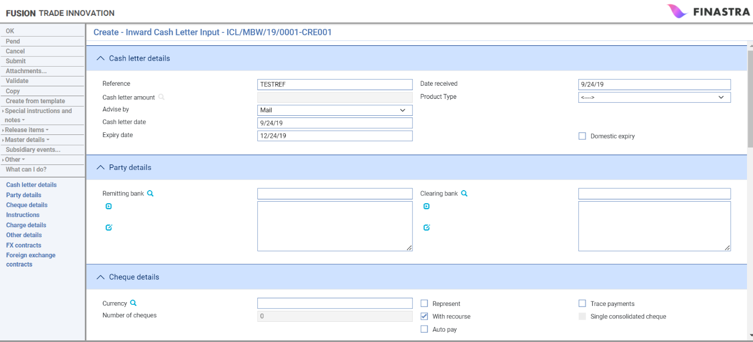

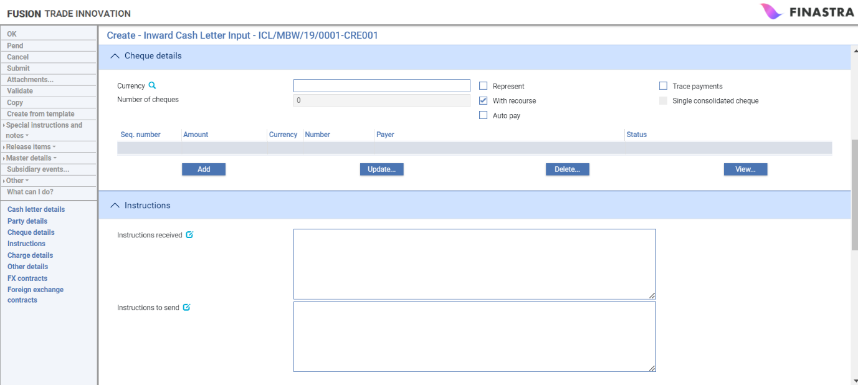

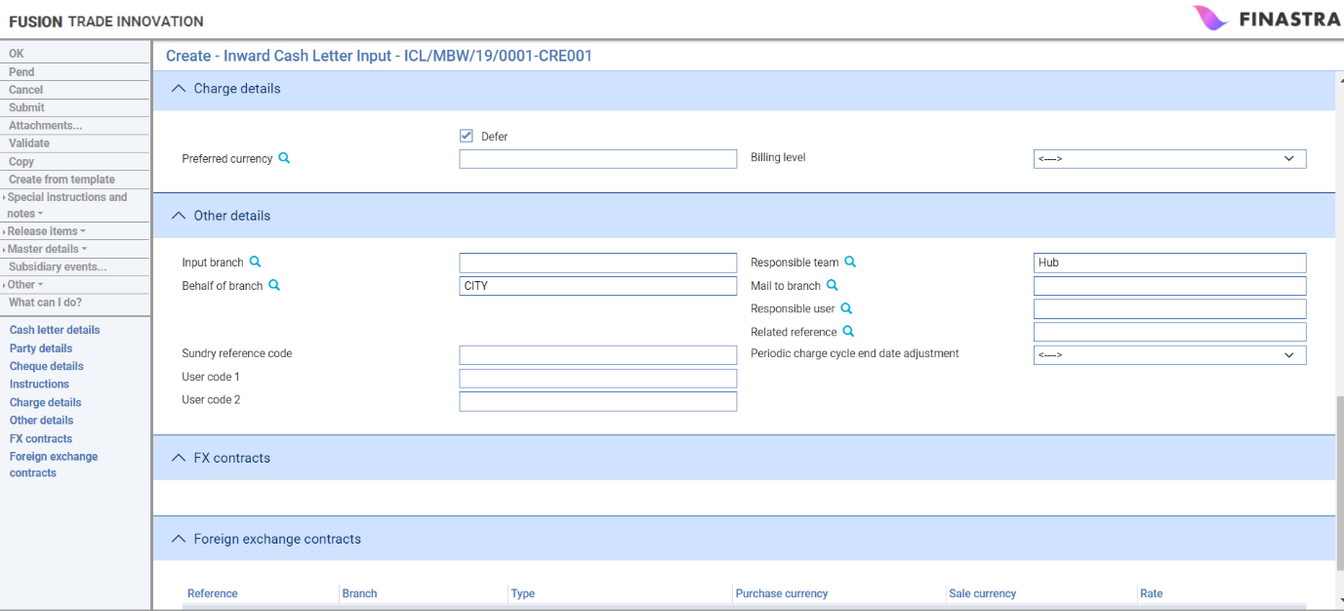

You can use the Copy button in the Create event's Input window to create a new cash letter from an existing one.

1. The instructions received with an inward cash letter and the instructions to send with an outward cash letter will copy only when clauses have been mapped to these fields. Any narrative you may have entered will not copy across.

The window uses the following panes:

* The Cash Letter Details pane (see page 6)
* The Party Details pane (see page 7)
* The Cheque Details pane (see page 7)
* The Instructions pane (see page 9)
* For outward cash letters, the Negotiation Details pane (see page 9)
* The Charges Details pane (see page 10)
* The Other Details pane (see page 10)
* The FX Contracts pane

The instructions on using the FX Contracts pane to enter details of foreign exchange contracts see the Common Facilities User Guide – Trade Innovation.

### The Cash Letter Details Pane

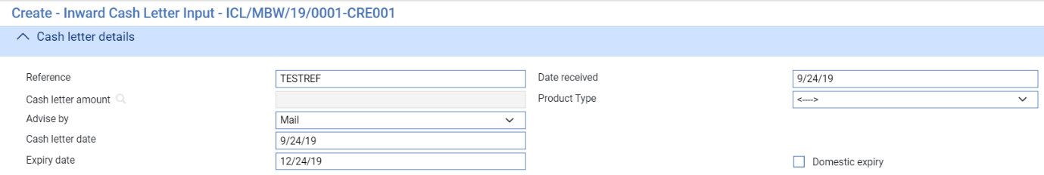

The following table explains what to enter into the fields in the Cash Letter Details pane:

|  |  |  |
| --- | --- | --- |
|  | Field | What to Enter |
|  | Reference | The reference number for the cash letter, as defined by the principal party. (For an outward cash letter, this would be the payee, and for an inward cash letter this would be the remitting bank.) |
|  | Date Received | The date on which the cheques were received. This field defaults to today's date but you can alter this as necessary. The date you enter must be today or earlier. |
|  | Cash Letter Amount | Automatically displays the total of all the cheque amounts entered in the cash letter. This is recalculated every time a cheque is added, deleted or updated. |
|  | Product Type | Allows a user defined product type to be entered. Depending on how your system has been configured, this field may be mandatory. |
|  | Advise By | Select the method by which you wish to send the cash letter advice. This may also be used for other documents where appropriate. |
|  | Cash Letter Date | The date on which the cheques were received. This field defaults to today’s date but you can alter this as necessary. The date you enter must be today or earlier. |
|  | Expiry Date | The date at which the cash letter will expire, and then subsequently be booked off and archived. In the case of automatic payment, this is set to the auto pay value date. |
|  | Domestic Expiry | By default, the days grace set up for overseas expiry is applied to cash letters. If you wish to use the days grace set up for domestic expiry, check this field. |

### The Party Details Pane

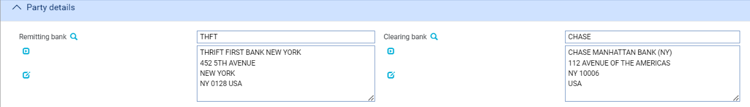

The fields in the Party Details pane are used to identify the remitting bank (the bank from which the cheques are received for clearing) and the clearing bank for inward cash letters; and the payee (the credit party of the cheques) and the correspondent (the party that is to receive the cheques for clearing) and their country for outward cash letters.

### The Cheque Details Pane

If system option ‘EnableSingleConsolidatedCheque’ is enabled, the new logical box ‘Single consolidated cheque’ allows the user to process the multiple cheques in a single consolidated cheque with different partial actions (Partial pay, partial return, partial represent and partial mixed). This system option automatically disables the auto-pay functionality and is applicable only to Inward Cash Letters.

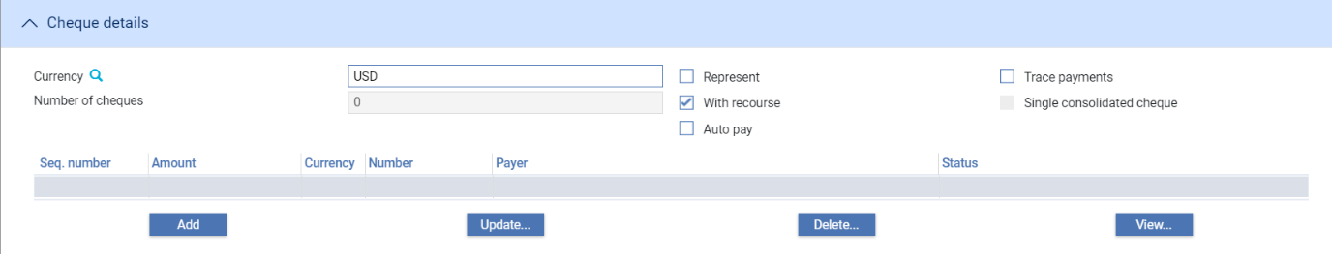

The Cheque Details pane is used to enter information about the cheques included in the cash letter.

The Add button is enabled once the currency of the cash letter is entered. It allows you to enter details of the actual cheques. The Update and Delete buttons allows you to change the details of an individual cheque or delete it in the usual way.

The following table explains what to enter into the fields in the Cheque Details pane:

|  |  |  |
| --- | --- | --- |
|  | Field | What to Enter |
|  | Currency | The currency for the cheques to be covered by the cash letter. You must enter a currency to activate the **Add** button, so that you can enter cheque details. |
|  | Number of Cheques | The total number of cheques associated with the cash letter. This is updated automatically as cheques are added or deleted. |
|  | Represent | Check the box if dishonoured cheques are to be presented again, as requested in advance by the payee on the outward cash letter. To de-select the option, click on the box again. |
|  | With Recourse | Check this field if the cash letter is with recourse. Negotiated payments or auto payments are made with recourse, so that any payments made can be recalled by your bank if necessary. (The default setting of this field depends on whether you are entering details of an inward cash letter or an outward cash letter; and on the setting of the OutCashLetterWithoutRecourse system option.) |
|  | Auto Pay | Check the box to automatically pay the cheques at a future value date. The system will change the status of all cheques to Autopaid, and generate the necessary accounting entries. |
|  |  | For inward cash letters, the Auto pay and Value Date fields may be replaced by a Payment Date field. (This is controlled by the system option CashLettersValueDate.)  If this is the case use the Payment Date field to enter the value date for the cash letter. The system will create a Settle event in the diary to settle the cash letter on the date entered here. |
|  | Single consolidated cheque | Check the box to allow the user to manually process the multiple cheques in a single consolidated cheque with different partial actions (Partial pay, partial return, partial represent and partial mixed). |
|  | Trace Payments | Check this field if you want the system to trace for payment of the cash letter. |

#### Entering Cheque Details

The Add button in the Cheque Details pane is enabled once the currency of the cash letter has been entered. It displays the Cheque Details window, which allows you to enter details of each of the cash letter's cheques.

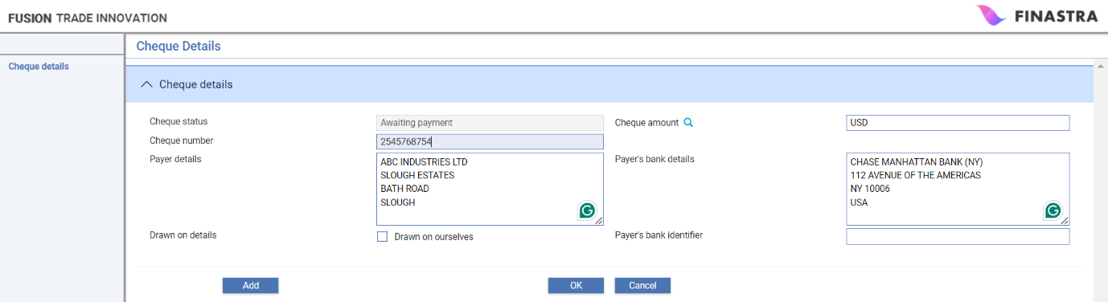

At least one cheque must be entered. The following table explains what to enter into the fields in this window to define a cheque:

|  | Field | What to Enter |
| --- | --- | --- |
|  | Cheque Status | The status of the cheque is assigned automatically and indicates how far it has been processed. This field defaults to 'Awaiting Payment' unless the cheque is to be automatically paid, in which case the status would be 'Autopaid'. |
|  | Cheque Amount | The amount of the cheque, in the currency of the cash letter. |
|  | Cheque Number | The cheque number that is printed on the cheque. If a cheque number is not entered a warning is displayed. |
|  | Drawn on Ourselves | For inward cash letters only, check this field to indicate that the cheque is drawn on your own bank. In other words, the system allows you to pay or return your own cheques internally without involving a clearing bank. If so, one of your bank's internal accounts (the actual payer's account or a branch suspense account, as entered in the Payer's Bank Identifier field) will be debited. The Payer's Bank Identifier field is displayed for this purpose when you check this field.  Leave the field unchecked to indicate that the cheque is drawn on another bank. |
|  | Payer Details | The payer details, as printed on the cheque. |
|  | Payer's Bank Details | The bank details of the payer, as printed on the cheque. |
|  | Payer's Bank Identifier | Used for inward cash letters with the Drawn On Ourselves field checked. Enter your bank's internal debit account or a customer account, so that payment can be made directly without involving the clearing bank. |

### The Instructions Pane

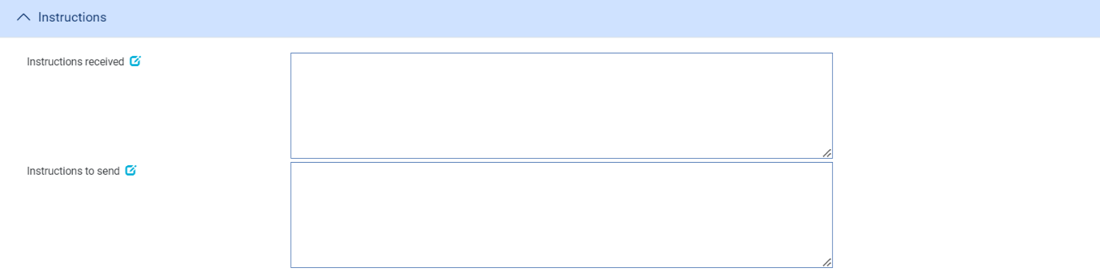

This Instructions pane allows you to enter any instructions that you have received or that are to be included in the cash letter, either as free format text or using pre-defined clauses.

### The Negotiation Details Pane

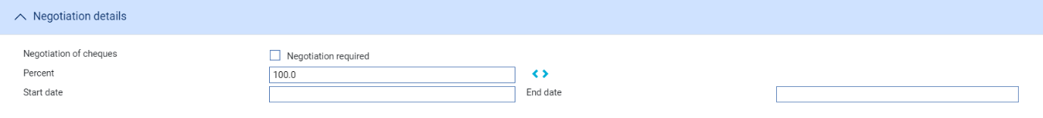

The Negotiation Details pane is displayed for outward cash letters only. The fields in this pane allow you to enter details of a negotiated payment that has been made to the payee in advance. Check the Negotiation Required field if a payment in advance has been negotiated.

The negotiation is shown either as a percentage of the total cash letter amount, or as an amount. Click on the  button to view the negotiation as an amount instead of a percentage.

Use the Start Date and End Date fields to enter the dates for the negotiation period. (These dates also allow an interest charge to be calculated for the negotiation.) When you check the Negotiation box, the Negotiation amount is shown as 100% of the cash letter amount by default, with a start date of today and the end date blank. Enter the values that you require.

The Start Date is the date on which the advance is to be credited, and represents the start of the interest period for the negotiated amount, if used for an interest charge. The End Date is the date on which the advance is to be repaid, and represents the end of the interest period for the negotiated amount, if used for an interest charge. In the case of automatic payment, the end date is set automatically to the Auto pay Value Date entered on the main input window.

1. The fields in the Negotiation pane are mandatory if the Negotiation Required field is ticked.

### The Charges Details Pane



The following table explains what to enter into the fields in the Charges Details pane:

|  |  |
| --- | --- |
| Field | What to Enter |
| Defer | Check this box if charges are to be deferred, or uncheck it if charges are to be taken when this event completes. |
| Preferred Currency | The currency in which your bank will collect the charges. The default currency value is taken from the charge currency specified in product options. For inward cash letters, this is the customer charge currency, and for outward cash letters the other party's charge currency.  You may override the default value. |
| Billing Level | Select whether charges for this cash letter should be billed at customer level, transaction level or product level. |

### The Other Details Pane

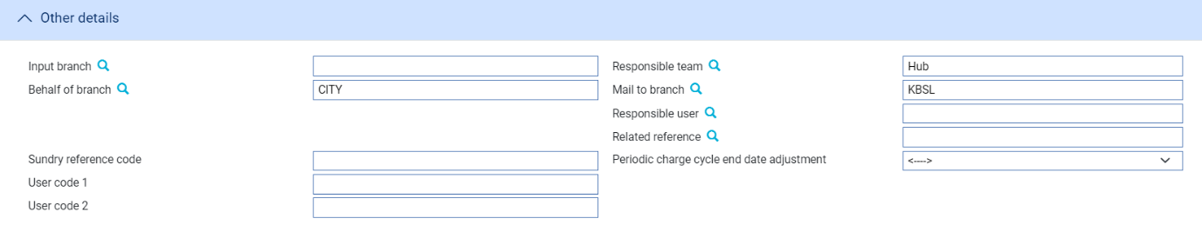

The following table explains what to enter into the fields in the Other Details pane:

|  | Field | What to Enter |
| --- | --- | --- |
|  | Input Branch | The input branch for the transaction. The input branch is set from either :   * the accounting branch from the user’s team, or * the transaction branch for user if the user has a default transaction branch or is locked to a specific branch, or * a branch associated with the user where the user can enter transactions for several branches for a team |
|  | Behalf of Branch | The behalf of branch for the transaction as entered by the user or set from the incoming SWIFT or gateway message. The behalf of branch determines the parameter sets that are to be used to generate charges, documents, postings, etc. during transaction processing. The branch can be changed to any other branch within the same main banking entity that shares the same parameter sets. |
|  | Responsible Team | The team that has overall responsibility for the master e.g. as the contact to resolve any queries or issues regarding the master and associated events. The system defaults the responsible team when creating the transaction as follows:   * Manual – set from team creating the transaction * Gateway – set from the team specified on the incoming message (if present and valid) otherwise to the team to which the transaction is assigned through workflow allocation based on the behalf of branch * SWIFT – set to the team to which the transaction is assigned through workflow allocation based on the behalf of branch   It can be changed, if required, to either the team associated with the primary customer, default team for the product or the user’s current team. |
|  | Mail To Branch | The mail to branch can be set to any branch within the main banking entity of the behalf of branch. |
|  | Responsible User | A user that has responsibility for the master e.g. as the contact to resolve any queries or issues regarding the master and associated events. This can be any user assigned to the responsible team. |
|  | User Codes | You may use this field to enter a value for analysis purposes. Your bank will have devised its own system for using this field. |
|  | Related Reference | A reference to any related master record, such as a cash letter. |

## The Cash Letters Master Summary Window

Once you have created a cash letter, the system will display the basic details of that cash letter using the Master Summary window.

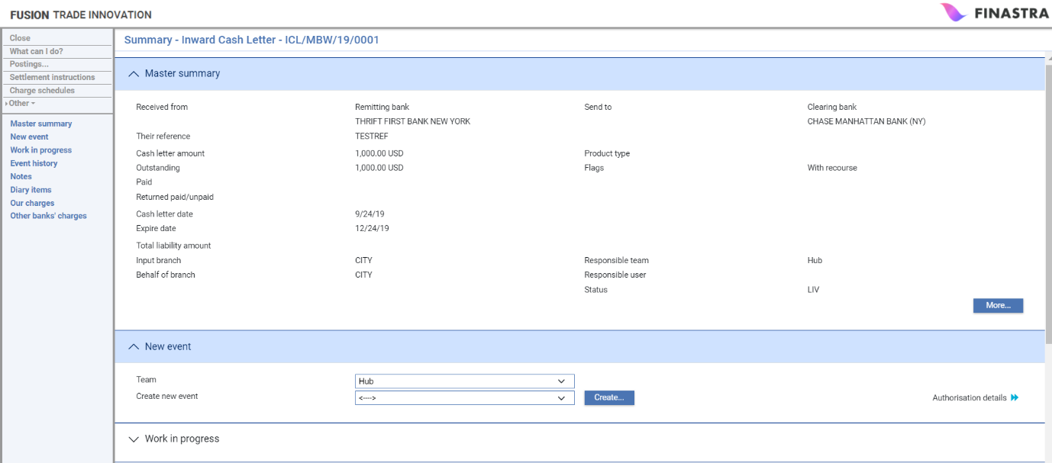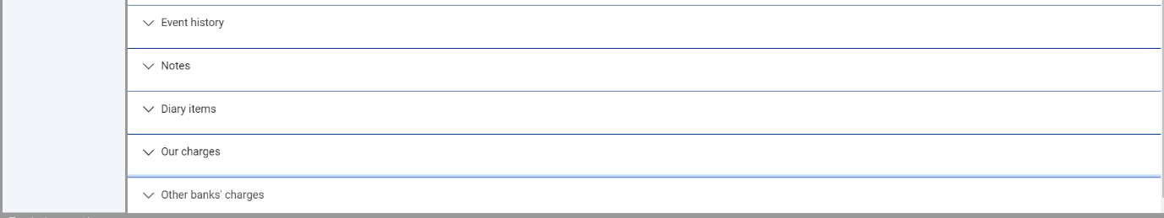

For more information on how the various panes and buttons in this window work see the Common Facilities User Guide – Trade Innovation.

# Settling a Cash Letter

## Settling a Cash Letter

The Settle event (see page 12) enables further cheque settlement processing for both inward and outward cash letters. As auto cheque payment processing is possible through the Create event, the Settle event is only expected to be used to process non-payment actions. This chapter explains how to pay cheques, return dishonoured cheques, adjust cheque payment already made, make further representation on cheques and correspond with other parties in relation to cheques.

The Settle event enables the cash letter to expire if its outstanding amount is reduced to zero as a result of automatic payment; it also lets you change the status of a previously expired cash letter to Live, if necessary.

The Settle event also allows user to handle multiple cheques in a single consolidated cheque by using different partial actions (partial pay, partial return, partial represent and partial mixed). This is applicable only for Inward Cash Letters.

### For Outward Cash Letters

As the remitting bank, you can use the system to settle outward cash letters that have been advised by the clearing system. Your settlement action depends on whether you have received a credit advice, advice of dishonour, cheque settlement advice, or credit adjustment advice.

The settlement advice may be received from the collecting bank by SWIFT, in which case the Settle event may have been created for you. Incoming SWIFT messages that may create the Settle event for a cash letter include:

* MT400 Advice of Payment
* MT450 Cash Letter Credit Advice
* MT455 Cash Letter Credit Adjustment Advice
* MT456 Advice of Dishonour

The system is able to set up settlement instructions at master level for the collecting bank from an incoming MT400, MT450, MT455 or MT456 if the account information is contained in the field 25 (Account identifier).

If the settlement advice is received on paper (by mail, telex or fax), you will need to create the Settle event and enter the details into the system manually. Details about the settlement advice are entered onto the main input window; details of how settlement is to be processed are entered on supplementary screens accessed by the Cheques and Instructions buttons.

You are able to:

* Receive payments from the collecting bank
* Collect your charges (plus any charges debited by the collecting bank), especially in a case of a dishonoured cheque
* Make payment (less charges) to the payee (your customer)
* Use the funds received to settle the negotiated payment made to the payee if cheques were negotiated
* Recall negotiated repayment from the payee if cheques are returned unpaid
* Return cheques unpaid to the payee if no further representation is to be made
* Refund auto payment relating to cheques returned unpaid
* Make adjustment to a payment already made as advised by the collecting bank

### For Inward Cash Letters

As the collecting bank, you can use the Settle event for an inward cash letter to process information you have collated about cheques that have been as advised by your clearing bank as paid or/and dishonoured (outside the system). You are able to:

* Manually update relevant cheque details
* Process cheques drawn on your banks directly without involving a clearing bank
* Make payment to the remitting bank
* Return cheques unpaid to the remitting bank
* Refund auto payment relating to cheques returned unpaid
* Make adjustment to a payment already made
* Collect your charges from the remittance or by debiting the remitting bank's account in a case of dishonour
* Handle multiple cheques in a single consolidated cheque with different partial cheque settlement actions.

A credit adjustment is necessary when a wrong cheque amount was previously paid due to incorrect cheque details held on the cash letter or to charges that were not deducted fully.

Multiple cheques can be handled via single consolidated cheque feature. Cheques may be set to Single Consolidated Cheque, which allows the user to manually process following partial actions:

* Partial payment of a consolidated single cheque leading to accounting, settlements, and generation of MT450 or alternative non-SWIFT based advice.
* Partial return of a consolidated single cheque leading to generation of MT456 or alternative non-SWIFT based advice.
* Partial representation of a consolidated single cheque leading to generation of MT499 or alternative non-SWIFT based advice.

This is only possible if SO ‘EnableSingleConsolidatedCheque’ is set to ‘Yes’.

1. When this system option is switched on, it automatically disables the auto-pay functionality and is applicable only for Inward Cash Letters.

When the Settle event for a cash letter has been completed, the system can issue a notification to the principal party. (For an outward cash letter, the payee is the principal party and for an inward cash letter, it is the remitting bank.) Depending on the settlement action, the notification may be one of the following:

* Credit Advice
* Advice of Dishonour
* Cheque Settlement Advice (either credit or dishonour)
* Credit Adjustment

As the collecting bank you are able to generate these advices (except the cheque settlement advice) as SWIFT MT450, MT455 and MT456 messages (which are specific to cash letters). Alternatively, your bank can issue advices as MT400s or free format MT499s.

For an inward cash letter where a payment date has been entered, the system will generate a Settle event during overnight processing when the payment date is reached. (This is only possible if the system option CashLettersValueDate is set to ‘Yes’.) Depending on how your system is configured, this Settle event may need manual input or review before it can complete.

## Settling a Cash Letter

The Settle event will either have been created automatically (and the basic data captured electronically), or you will need to create the event manually.

To manually settle the cash letter, in the Master Summary window select 'Settle' from the Create New Event drop-down list and click Create. The system opens the event at either a Log step or Input step. Depending on how your system is configured, panes and fields available in log steps can be tailored for each data capture step. See the *SDK - Screen Tailoring Guide* – Trade Innovation for details.

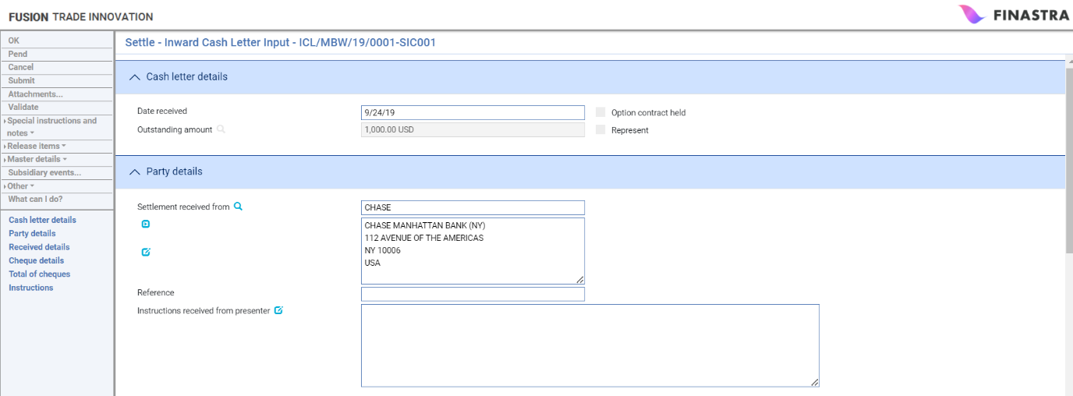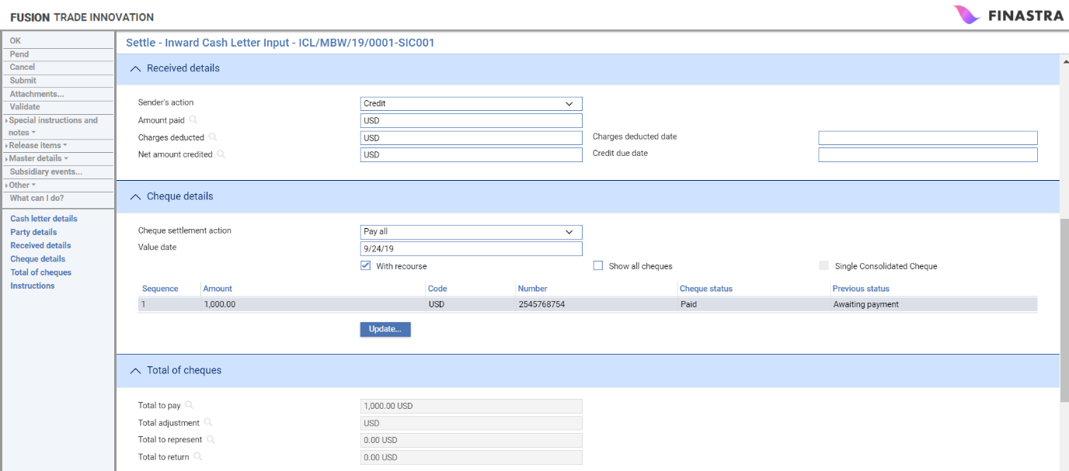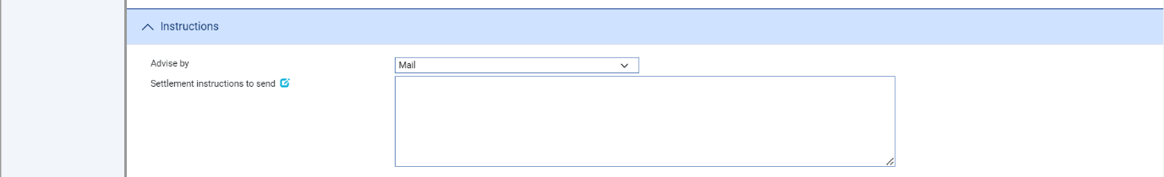

The same input fields are used at a Log and an Input step. In the case of an outward cash letter, some of the fields will have been filled automatically by the system if the event is created by an incoming SWIFT message. Depending on how your system is configured, panes and fields available in log steps can be tailored for each data capture step. See the *SDK - Screen Tailoring Guide* – Trade Innovation for details.

For events created from SWIFT messages use the SWIFT button to view full details of messages, especially for the following reasons:

* View MT455 to read details of the original payment which will help you to identify cheques requiring adjustment
* View MT456 to read details of fees, dishonoured items and reasons for dishonour which will help you to identify cheques advised as dishonoured

The window used to enter settlement details has the following panes:

* The Cash Letter Details pane (see page 15)
* The Party Details pane (see page 16)
* The Received Details pane (see page 16)
* The Cheque Details pane (see page 19)
* The Total of Cheques pane (see page 20)
* Partial Cheque Details (see page 21)
* The Instructions pane (see page 21)
* For outward cash letters, the Negotiation Details pane (see page 21)

### The Cash Letter Details Pane



The following table explains what to enter into the fields in the Cash Letter Details pane:

|  |  |  |
| --- | --- | --- |
|  | Fields | What to Enter |
|  | Date Received | The date that the settlement advice relating to the cash letter was received. This defaults to today, but may be set to earlier. |
|  | Outstanding Amount | The outstanding amount and currency of the cash letter awaiting payment displayed automatically (whereas the Original Amount is the total amount of the cash letter negotiated). |
|  | Option Contract Held | Indicates whether any FX contracts are pre-defined. |
|  | Represent | Indicates whether the principal party requested that you make further representation on any dishonoured cheques. |
|  | Negotiation | Indicates on the outward cash letter whether a negotiated payment in advance was made. |

### The Party Details Pane

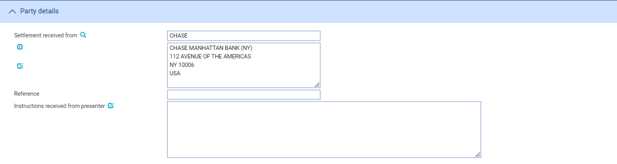

The following table explains what to enter into the fields in the Party Details pane:

|  |  |  |
| --- | --- | --- |
|  | Fields | What to Enter |
|  | Settlement Received From | The party who has sent a settlement advice or query/answer which prompted you to create the event. For an outward cash letter, it is the collecting bank; for an inward cash letter, it is the clearing bank. This pane defaults to the party reference and customer details of the non-principal party. |
|  | Reference | The reference received from the remitting bank for the outward cash letter. |
|  | Instructions Received from Presenter | Any instructions that were received, including any details of the sender's action. |

### The Received Details Pane

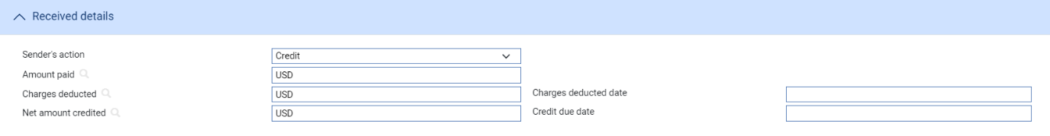

The Received Details pane is used to define how the settlement will be processed. The Sender's Action field allows you to identify the settlement instructions received. It provides the following options:

* 'Credit', to pay all cheques (see page 17)
* 'Dishonour', if one or more cheques are being dishonoured (see page 17)
* 'Adjust Credit', if an adjustment is needed to a previously paid cheque (see page 18)
* 'Non-principal's Other' (see page 18), if settlement involves a mixture of credited and dishonoured cheques to be processed through a single Settle event
* 'Principal's Other' (see page 19), when the settlement instruction is received from the payee (in the case of an outward cash letter) or the remitting bank (in the case of an inward cash letter)
* Partial (see page 19), if multiple cheques are to be handled via a single consolidated cheque feature.

The Cheques pane (see page 19) permits you to select and process one or more cheques individually.

#### Pay All Cheques

If the settlement instruction received for a cash letter from the non-principal party is to pay all cheques, then leave the Sender's Action field set to 'Credit' (this is the default action when the Settle event is created manually).

The following table explains what to enter into the fields that are displayed:

|  |  |
| --- | --- |
| Fields | What to Enter |
| Amount Paid | The total face amount of the cheques advised as paid. |
| Charges Deducted | The charges that have been deducted for the transaction by the non-principal parties.  You need to manually enter the collecting bank's charge (that is equivalent to this amount) in the Other Bank's Charges pane on the Charge Summary window. |
| Charged Deducted Date | A value date for the charges, if it is different from that of the net payment. |
| Net Amount Credited | The amount being paid to your bank. |
| Credit Due Date | The date on which the net amount is to be credited. |

#### Dishonouring One or More Cheques

If the settlement instructions indicate the dishonouring of one or more of the cheques, then select 'Dishonour' in the Sender's Action field.

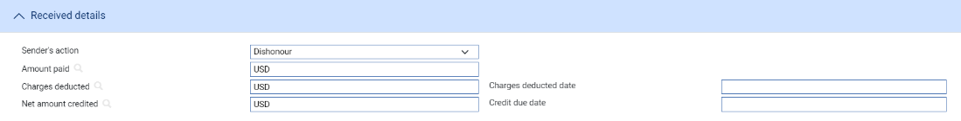

The following table explains what to enter into the fields that are displayed:

|  |  |
| --- | --- |
| Fields | What to Enter |
| Amount Dishonoured | The face amount of the cheques advised as dishonoured. |
| Dishonoured Date | A value date associated for the amount dishonoured, if known. |
| Charges Deducted | The charges that were taken by the non principal party for the transaction. |
| Charges Deducted Date | A value date associated for the charges deducted. |
| Net Amount Credited | The net amount being credited as a result of the dishonoured cheque(s), after charges have been deducted. |
| Credit Due Date | The value date for the net amount being credited. |

#### Making an Adjustment

To adjust a previously credited payment as advised by the non-principal party, select 'Adjust Credit' in the Sender's Action field.

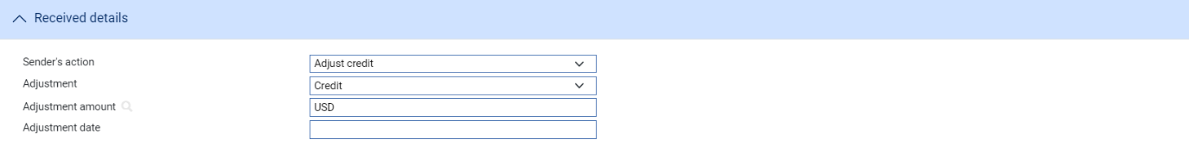

The following table explains what to enter into the fields that are displayed:

| Fields | What to Enter |
| --- | --- |
| Adjustment | Select the type of adjustment - credit or debit - from the drop-down list. |
| Adjustment Amount | The amount by which the cash letter is advised as adjusted.  The Instructions Received field or the incoming SWIFT MT455 will contain details of the original payment that will help you to identify the affected cheques. |
| Adjustment Date | The date of the adjustment. |
| Net Amount Credited | The net amount being credited as a result of the adjustment, after charges have been deducted. |
| Credit Due Date | The value date for the net amount being credited. |

#### Mixed Settlement

If the settlement involves a mixture of credited and dishonoured cheques that need to be processed through a single Settle event, select 'Non-principal's Other' in the Sender's Action field.

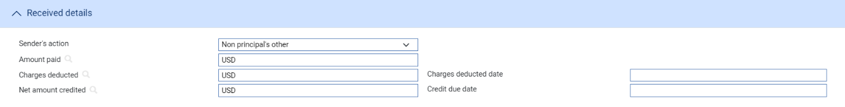

The following table explains what to enter into the fields that are displayed:

|  |  |
| --- | --- |
| Fields | What to Enter |
| Amount Paid | The total face amount of the cheques advised as paid. |
| Amount Dishonoured | The total face amount of the cheques advised as returned. |
| Dishonoured Date | A value date associated for the amount dishonoured, if known. |
| Charges Deducted | The charges that have been deducted for the transaction by the non principal parties. Also enter the value date for the charges, if it is different from that of the net payment.  You need to manually enter the collecting bank's charge (that is equivalent to this amount) in the Other Bank's Charges pane on the Charge Summary window. |
| Charges Deducted Date | A value date for the charges, if it is different from that of the net payment. |
| Net Amount Credited | The net amount of the credit, after charges have been deducted. |
| Credit Due Date | The value date for the net amount credited. |

#### Other Requests

When the Settle event is initiated by the receipt of a message from the principal party, you can 'select Principal's Other' in the Sender's Action field to make further representation to the collecting bank, for example to send a request for clarification of the advice you had previously sent them, or for repayment of the negotiated payment. 

Further details can be entered in the fields in the Instructions pane.

#### Partial

If the settlement involves multiple cheques that need to be processed through a single consolidated cheque in single Settle event, select Partial' in the Sender's Action field.

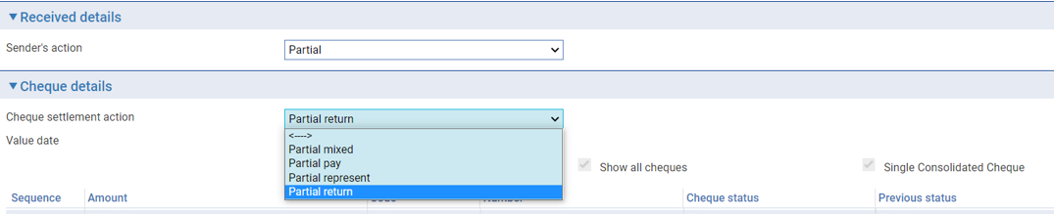

### The Cheque Details Pane

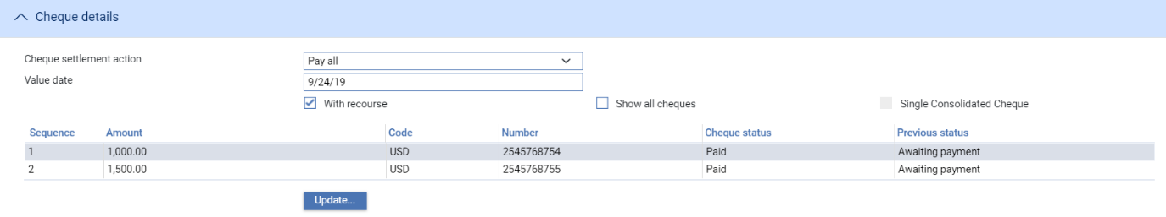

The **Cheque Settlement Action** field allows you to apply settlement actions to the cheques within the cash letter, as appropriate to the received instructions. The **Cheque Settlement Action** field defaults to 'Pay All Cheques', but you can use the drop-down list to select any of the following actions:

* Pay all cheques
* Pay selected cheques only
* Return all cheques unpaid
* Return selected cheques unpaid
* Represent selected cheques
* Adjust selected cheques that have been paid
* Specify a mixed settlement (credits and dishonours)
* Specify other (if it is none of the above)
* Partial mixed
* Partial pay
* Partial return
* Partial represent

Click **Refresh** once you have selected a value.

The **Value Date** field defaults to the credit due date given on the Received From details. You can change this date, for example to allow for cheque clearing.

Any payment you may make in this event may be with or without recourse. The default value for this field is With Recourse, and the box is checked accordingly.

The Cheque Details pane lists cheques awaiting settlement. The Cheque Status column indicates the current status of the cheques, as you are processing them on this window. The Previous Status column shows the status of the cheque at the time it was first entered into the Settle event. Status values change with different settlement actions.

The Show All Cheques check box allows you to toggle between displaying all cheques on the cash letter, or viewing only those that are relevant to the selected cheque settlement action. Press Refresh if you change the value in the Show All Cheques field.

Selecting settlement actions that apply to all listed cheques will automatically change the status of all the cheques in the Cheque Details pane. For example, if you select the Return All Unpaid option from the drop-down list of cheque settlement actions, the status of all the cheques in the Cheque Details pane will be updated to Returned.

However, if you select a settlement action that applies only to selected cheques, you must select each affected cheque in the Cheque Details pane and click on the Update button to manually amend its status. The Cheque Details window appears.

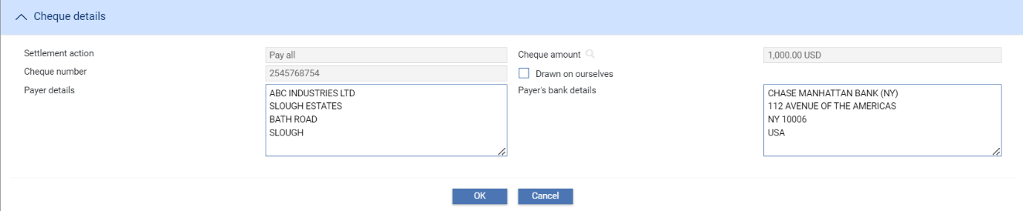

The status values that are available for each cheque in Cheque Status drop-down list are determined by the current status value of the cheque and the Cheque Settlement Action selected on the Cheques input window. For cheques that have already been paid or returned to the payee, no further status changes are possible.

If you need to make an adjustment (either an increase or a decrease) to a cheque that has been paid automatically, select a settlement action of 'Adjust Selected Paid' in the Cheque Details pane and click **Refresh**. The system displays all auto paid cheques for the cash letter in the Cheque Details pane. Select the cheque to be adjusted, and click the **Update** button.

Once you have entered the amendment, click the **OK** button. The status of the selected cheque on the Cheques input window will be automatically updated to show that the status has been amended from 'Auto Paid' to 'Auto Paid Adjusted'.

### The Total of Cheques Pane

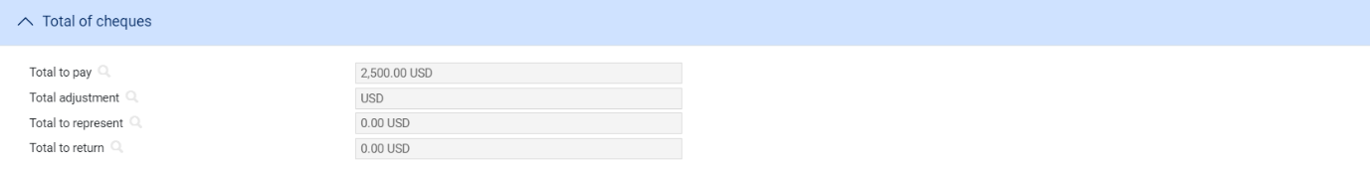

The following table explains what the fields in the Total of Cheques pane show:

|  |  |
| --- | --- |
| Fields | What it Shows |
| Total to Pay | The calculated total amount of cheques identified for payment, and does not reflect charges. Ensure this amount matches with the face amount that is advised as paid, by selecting relevant cheques for payment. Otherwise, request clarification from the collecting bank.  Payment on a cheque that doesn't reconcile can be postponed, to be processed later as an adjustment during a subsequent Settle event. |
| Total Adjustment | If the cheque settlement action is set to 'Adjust Selected Paid', this field displays the difference between total cheque amount increased and the total cheque amount decreased. |
| Credit/Debit Adjustment | Displayed if the cheque settlement action is set to 'Adjust Selected Paid' to indicate the amount of the adjustment and whether it is a debit or a credit. |
| Total to Represent | The calculated total amount of cheques identified for re-presentation, including those which were previously auto paid. |
| Total to Return | The total calculated total amount of cheques identified for returning, including those that were previously auto paid. |

#### Partial Cheque details

If the settlement involves multiple cheques that need to be handled by a single consolidated cheque through a single Settle event, select Partial' in the Sender's Action field.

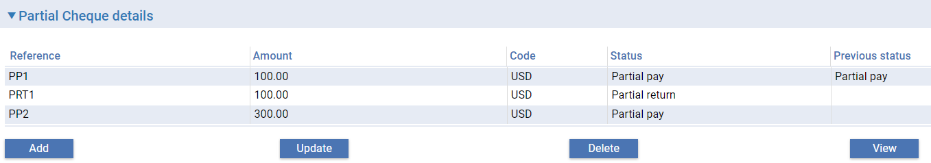

### The Instructions Pane

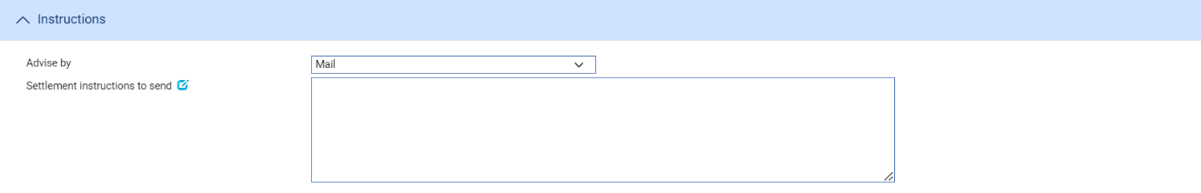

The Instructions pane allows you to enter any instructions that are to be sent to the principal party with the settlement advice. (For inward cash letters the principal party is the remitting bank, for outward cash letters it is the payee.)

Use the **Settlement Instructions to Send** field to enter any instructions that are to be sent with the settlement.

If one or more cheques are dishonoured, then use the **Reasons for Dishonour** field to enter details of why the cheques have been dishonoured; and the Dishonoured Items Details to enter detail of the cheques that have been dishonoured.

Use the **Advise By** field to select the method to be used to transmit the advice of settlement.

### The Negotiation Pane

For outward cash letter, the Negotiation Details pane allows you to view the negotiation terms that have been entered onto the system when the cash letter was created, and to enter negotiation repayment details for outward cash letters.



1. Negotiation applies to the cash letter, not to any specific cheques.

The fields on the Negotiation Details pane are automatically completed with the details from the Create event. The Original Amount is the total amount negotiated through the Create event, and the Outstanding Amount is the negotiation amount that is still outstanding after the negotiated payment.

# Adjusting a Cash Letter

This chapter explains how to adjust a cash letter using the system.

## Adjusting a Cash Letter

The system includes an Adjustment event, which allows you to correct mistakes on cheques awaiting payment that were made when the cash letter was being entered. However, you cannot alter the product, your bank's reference to the cash letter, or the status of the master record, nor are they received on date, negotiation details, instructions received, and instructions to send relevant to the Adjust event.

Once you have initiated an adjustment event, the system will prevent you from opening any other event for the cash letter until the Adjustment event has completed. If you attempt to open an Adjustment event while another event for the master is in progress, the system will warn you of the fact and prompt you to abort the Adjustment event. Unless you are attempting to make an adjustment to allow the pre-existing event to complete, you should abort the Adjust event and wait until the pre-existing event has completed before attempting the adjustment event again. If you continue with the Adjustment event, then the system will prevent any further work on the pre-existing event until the adjustment event has completed.

Note that, if you complete an Adjustment event while there is another event in progress (that is, an event pended at the Input step, or awaiting review or authorisation), then when you open that event to continue work on it, the system produces a warning advising you that the database may have changed since the event was initiated and identifying the Adjust event responsible. This allows you to view the Adjustment event and identify what has changed.

1. The Adjustment event is designed to allow you to make changes where you need to alter details but do not need to notify other parties. If you make any changes using this functionality, you should ensure that the accounting implications are resolved. Use the event cautiously, as certain changes may require manual accounting entries to be made and parties involved on the cash letter to be notified.

For instructions on using the Manual Bookkeeping event see the Common Facilities User Guide – Trade Innovation.

With the appropriate master record open, in the Master Summary window select 'Adjustment' from the Create New Event drop-down list and press Create. The system opens the event at either a Log step or an Input step. Depending on how your system is configured, panes and fields available in log steps can be tailored for each data capture step. See the *SDK - Screen Tailoring Guide* – Trade Innovation for details.

A Log step and an Input step use the same input fields. Depending on how your system is configured, panes and fields available in log steps can be tailored for each data capture step. See the *SDK - Screen Tailoring Guide* – Trade Innovation for details. These display the information already entered for the cash letter, which you can overtype.

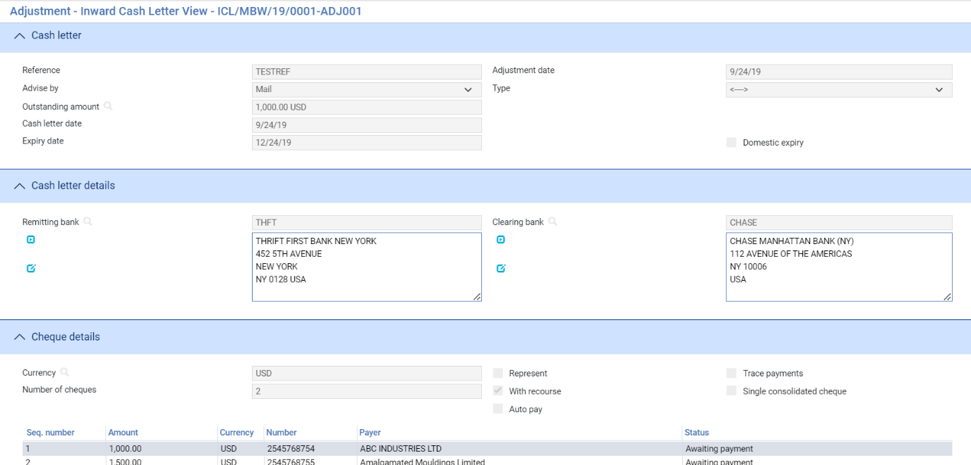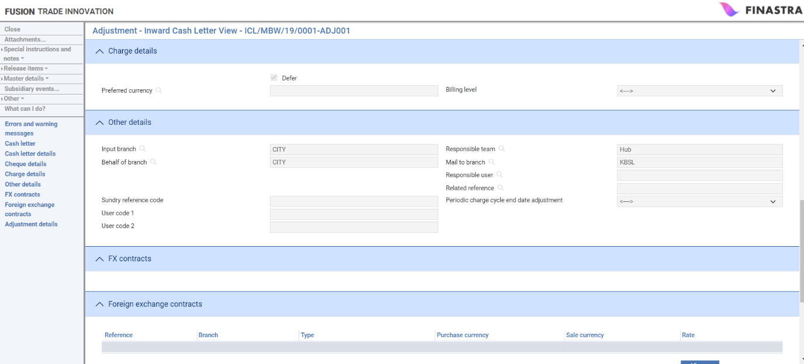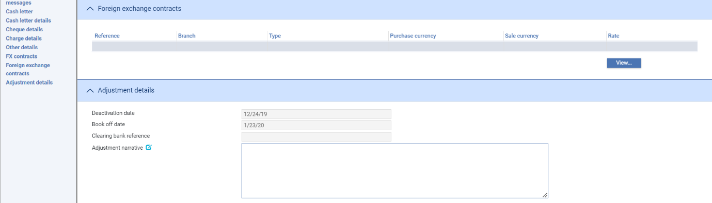

The window contains additional fields. The following table lists these and explains what you can enter into them:

| Fields | What to Enter |
| --- | --- |
| Adjustment Date | The date that the adjustment was made. This field defaults to today's date, but you can overtype this if necessary. |
| Outstanding Amount | The outstanding amount on the cash letter. This field is filled in automatically. |
| Deactivation Date | The system displays the date on which the cash letter will become inactive (after its expiry date and any days grace period has elapsed). You can amend this date.  See the System Tailoring User Guide – Trade Innovation for the days grace period. |
| Book Off Date | The system displays the cash letter's book-off date, which you can amend. The system will then book off the cash letter when the new book-off date is reached. |
| Clearing Bank Reference | The reference on the cash letter for the non-principal party. |
| Adjustment Narrative | Free format text that describes your reason for making the adjustment. |

# Appendix Status Values

This appendix lists cheque status values and shows the effect of settlement actions on the status of a cheque.

## Cheque Status Values

|  |  |
| --- | --- |
| Status | What it Means |
| Awaiting Payment | The cheque settlement has not yet been processed. For example, it has not yet been paid, or returned. |
| Re-presented | To be presented again. This may ultimately lead to payment or to its being advised as unpaid again. |
| Returned | The cheque is advised as unpaid, and is returned to the payee. It is regarded as unpaid, and no further processing is required on the cash letter. |
| Auto Paid | The cheque was entered at the Create event with a future value date, which may have passed or not yet be due.  The forward dated postings representing funds movements are passed to the back office system as projections, where they can be included in cash and nostro position enquiries and in future maturity reporting. When the value date of these postings is reached, the batch process in the system changes them from projections to actual funds movements. This means that auto paid postings are passed to the back office system as actual funds movement when their value date is reached. |
| Auto Paid Returned | A previously auto paid cheque is dishonoured, so the payment is refunded and the cheque returned unpaid. |
| Auto Paid Represented | A previously auto paid cheque is dishonoured, but further re-presentation is to be made. (This still counts as auto paid, because the refund is not yet made). |
| Paid | The cheque is paid through the Settle event on receipt of payment or a credit advice. |
| Paid Returned | A previously paid cheque is dishonoured, and the payment is refunded and the cheque returned unpaid. This is achieved through an adjustment to the cheque amount. |
| Partial Pay | The cheque is paid partially through the Settle event on receipt of payment or a credit advice via single consolidated cheque. |
| Partial Return | The previously paid/partial paid cheque is returned and the payment is refunded via single consolidated cheque. |
| Partial Represent | To be presented again. This may ultimately lead to payment or to its being advised as unpaid again. |
| Partial Mixed | To show the multiple partial cheque settlement actions available in a single consolidated cheque. |

## The Effect of Settlement Actions on a Cheque's Status

|  |  |  |  |
| --- | --- | --- | --- |
| Cheque Settlement Action | Affects Cheques with the Following Status | Status Remains Unchanged or Automatically Changes to | Change to a Selected Cheque Status Possible |
| Pay all | Awaiting payment  Represented | Paid  Paid | No  No |
| Pay Selected | Awaiting payment  Represented | Awaiting payment  Represented | Yes, to Paid  Yes, to Paid |
| Return All Unpaid | Awaiting payment  Represented  Auto paid  Auto paid represented | Returned  Returned  Auto paid returned  Auto paid returned | No  No  No  No |
| Return Selected Unpaid | Awaiting payment  Represented  Auto paid  Auto paid represented | Awaiting payment  Represented  Auto paid  Auto paid represented | Yes, to Returned  Yes, to Returned  Yes, to Auto paid returned  Yes, to Auto paid returned |
| Represent Selected | Awaiting payment  Auto paid | Awaiting payment  Auto paid | Yes, to Represented  Yes, to Auto paid represented |
| Adjust Selected Paid | Paid  Auto paid | Paid, or Paid Adjusted, or Paid Returned (if a full refund is made)  Auto paid, or Auto Paid Adjusted, or Auto Paid Returned (if a full refund is made) | No  No |
| Mixed Settlement | Awaiting payment  Represented  Auto paid  Auto paid represented | Remains unchanged | Yes, to Paid, or Returned, or Auto paid returned, or Represented, or Auto paid |
| Other | All status | No change | No |
| Partial Pay | Awaiting payment | Partial Pay | No |
| Partial Return | Partial Pay | Partial Return | Yes, to Partial Pay |
| Partial Represent | Awaiting payment  Partial Pay | Partial Represent  Partial Represent | No  No |
| Partial Mixed | Awaiting payment  Partial Pay  Partial Return  Partial Represent | Partial Mixed  Partial Mixed  Partial Mixed  Partial Mixed | No  No  No  No |

## Specific Combination of Sender’s action and Cheque settlement actions

If the new SO FilterChqSettlementActions is enabled as Yes, a specific filtering is applied for the available cheque settlement action list depending on the selected Sender's action. Accordingly, the below combination will be effected:

|  |  |
| --- | --- |
| Sender’s Action | Corresponding Cheque Settlement Action(s) |
| Credit | Pay all  Pay selected |
| Adjust credit | Adjust selected paid |
| Dishonour | Return all unpaid  Return selected unpaid  Represent selected |
| Non principal's other | Pay all  Pay selected  Return all unpaid  Return selected unpaid  Represent selected  Other  Mixed Settlement |
| Principal's other | Pay all  Pay selected  Return all unpaid  Return selected unpaid  Represent selected  Other  Mixed Settlement |
| Partial | Partial Pay  Partial Return  Partial Represent  Partial Mixed |